[1] CSA-1560 CLOUD COMPUTING LAB PRACTICAL

7.Create a simple cloud web application for student counselling system using any

Cloud Service Provider to demonstrate SaaS with the fields of student name,

age, address, phone, subjects studied, Year of passing, percentage of marks,

domain interest, etc.

STEP-1:

Login into zoho.com and create an account.Then go to zoho creator and create a new application starting with a new form.Add or insert the required fields.

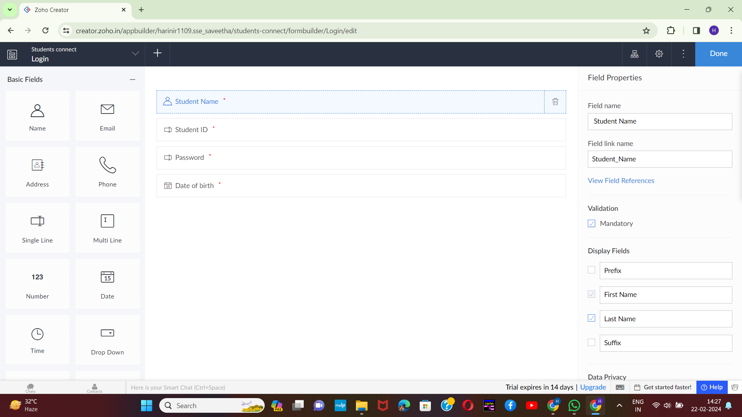

STEP-2:

Execute or run the model and get the required login form in live.

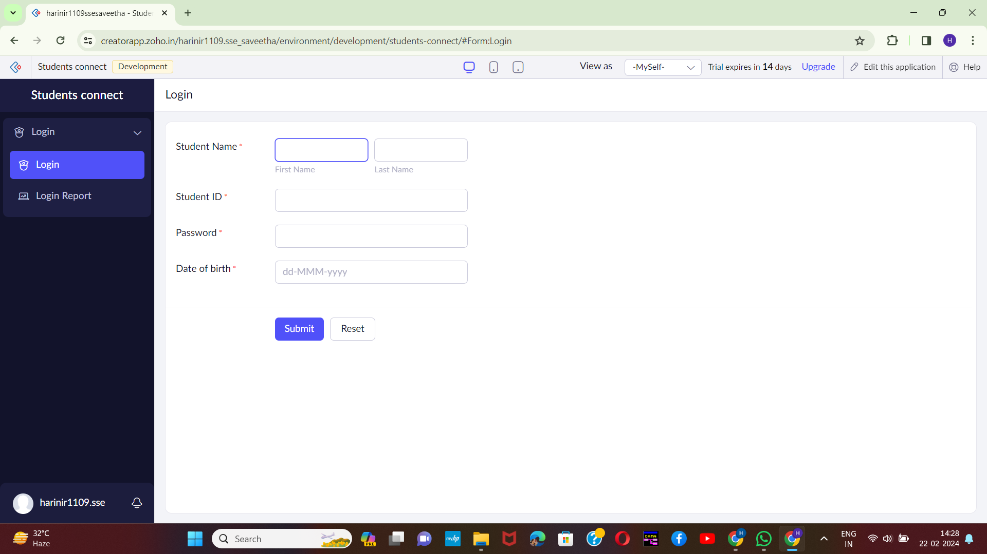[2]

STEP-3:

Next step is to add another form which consists of students details with the fields.

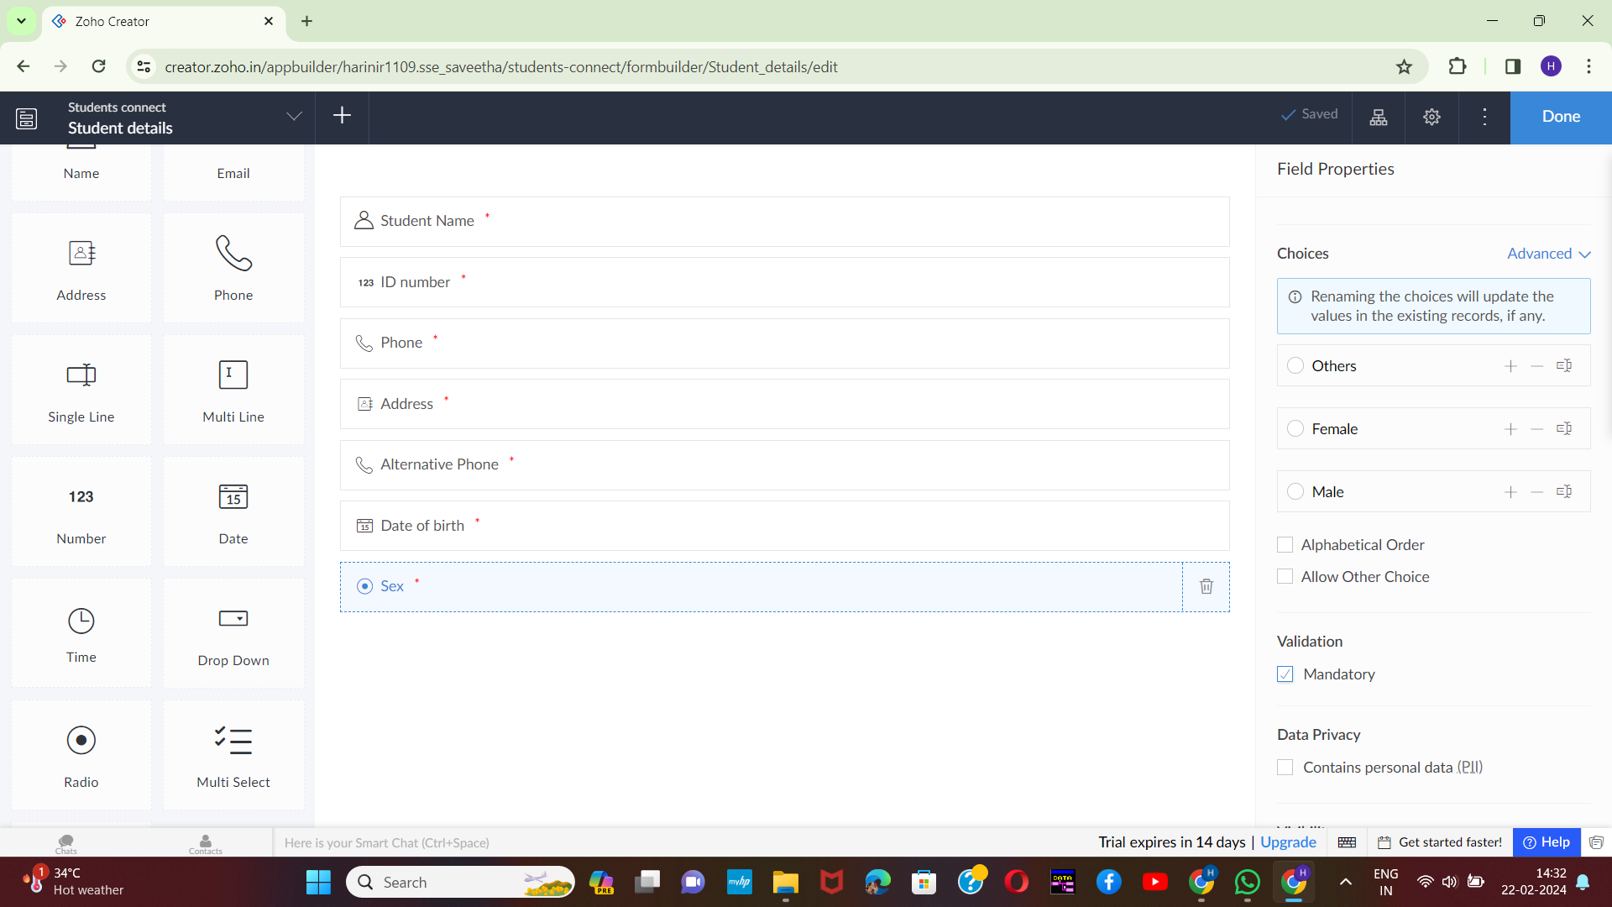

[3]STEP-4:

Execute or run the model and get the required students details from live.

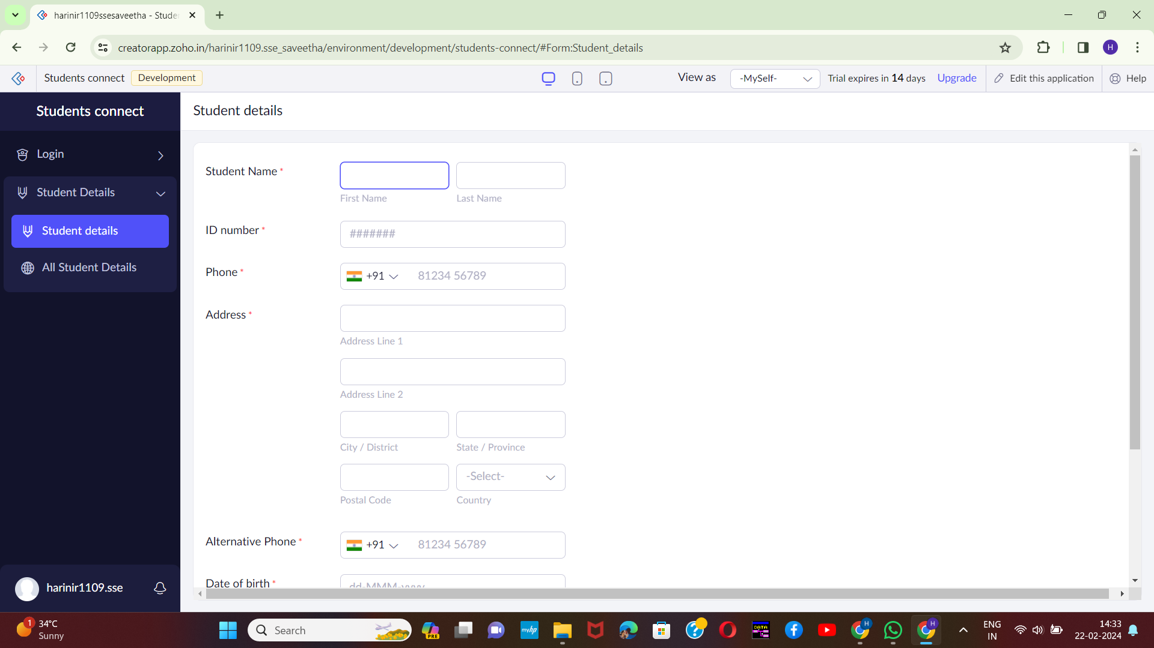

STEP-5:

Next step is to add another form which consists of scope of study details with the fields.

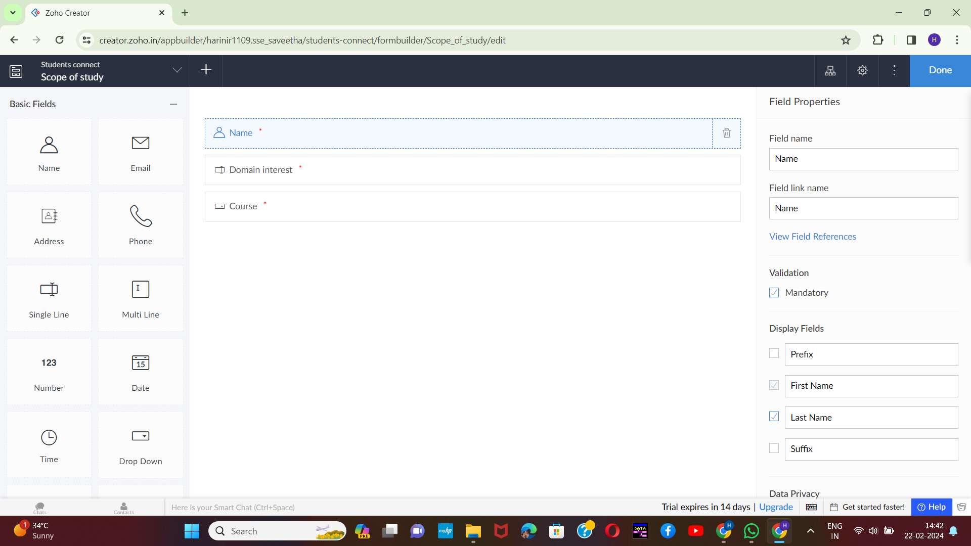[4]

STEP-6:

Execute or run the model and get the required study scope details from live.

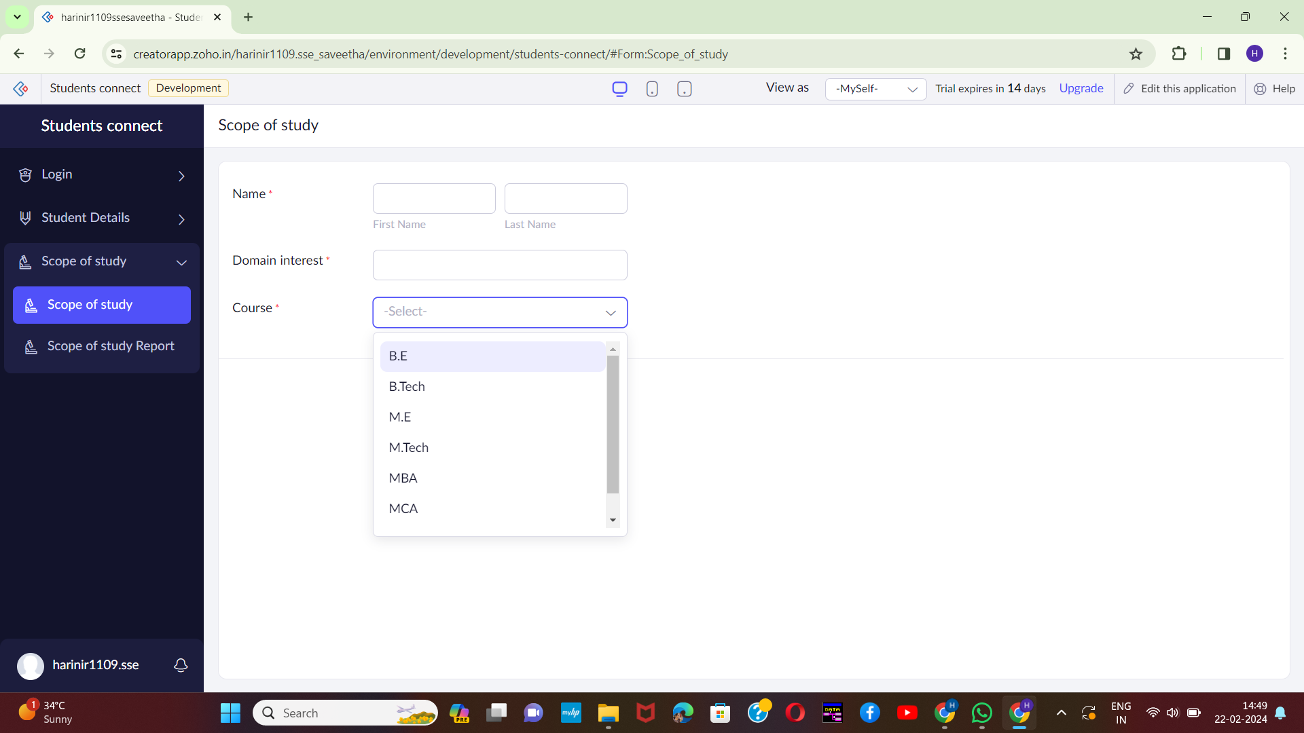

[5]

STEP-7:

Next step is to add another form which consists of past record of students details.

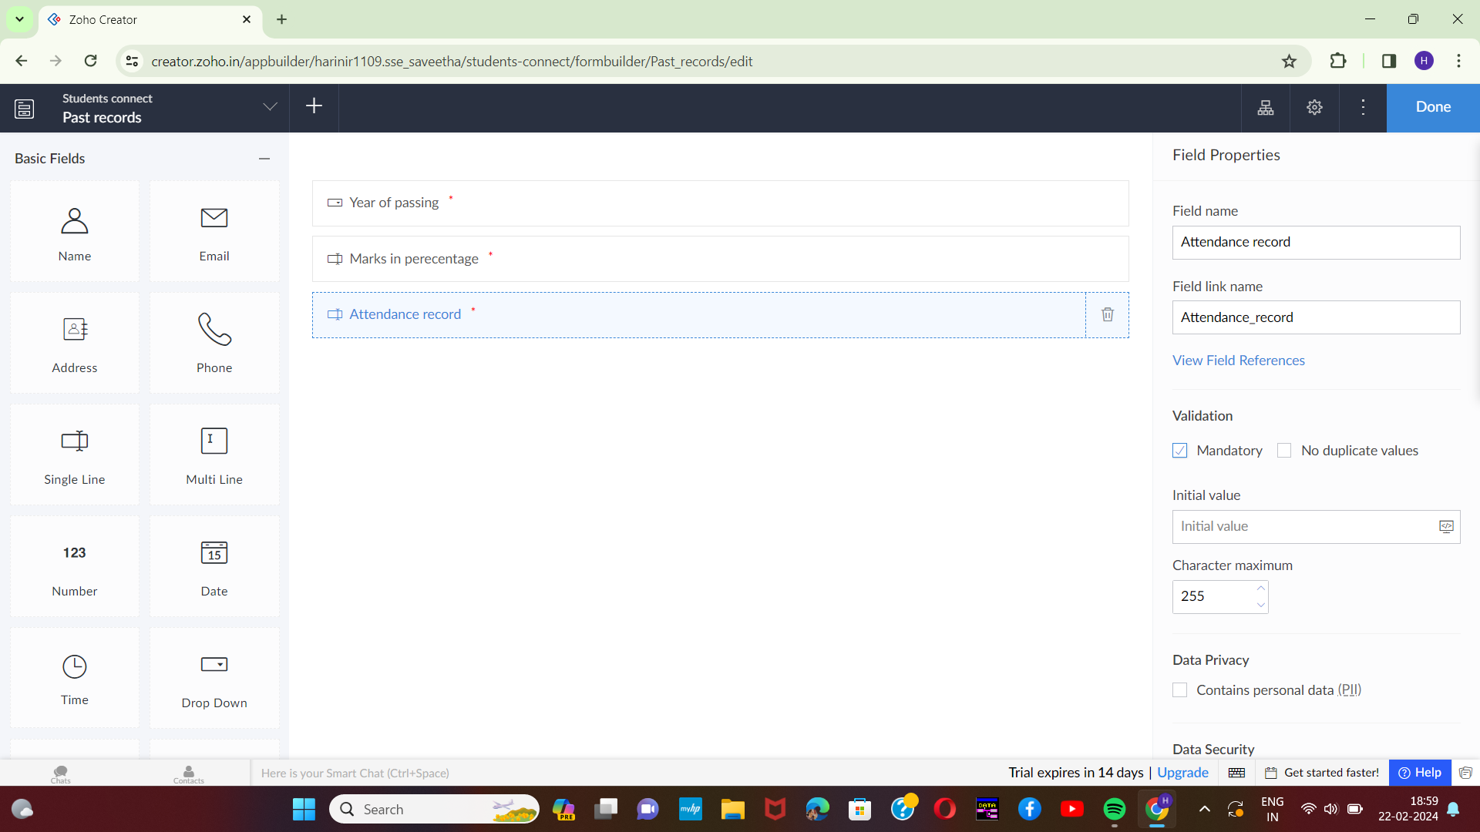

STEP-8:

Execute or run the model and get the required past record of students from live.

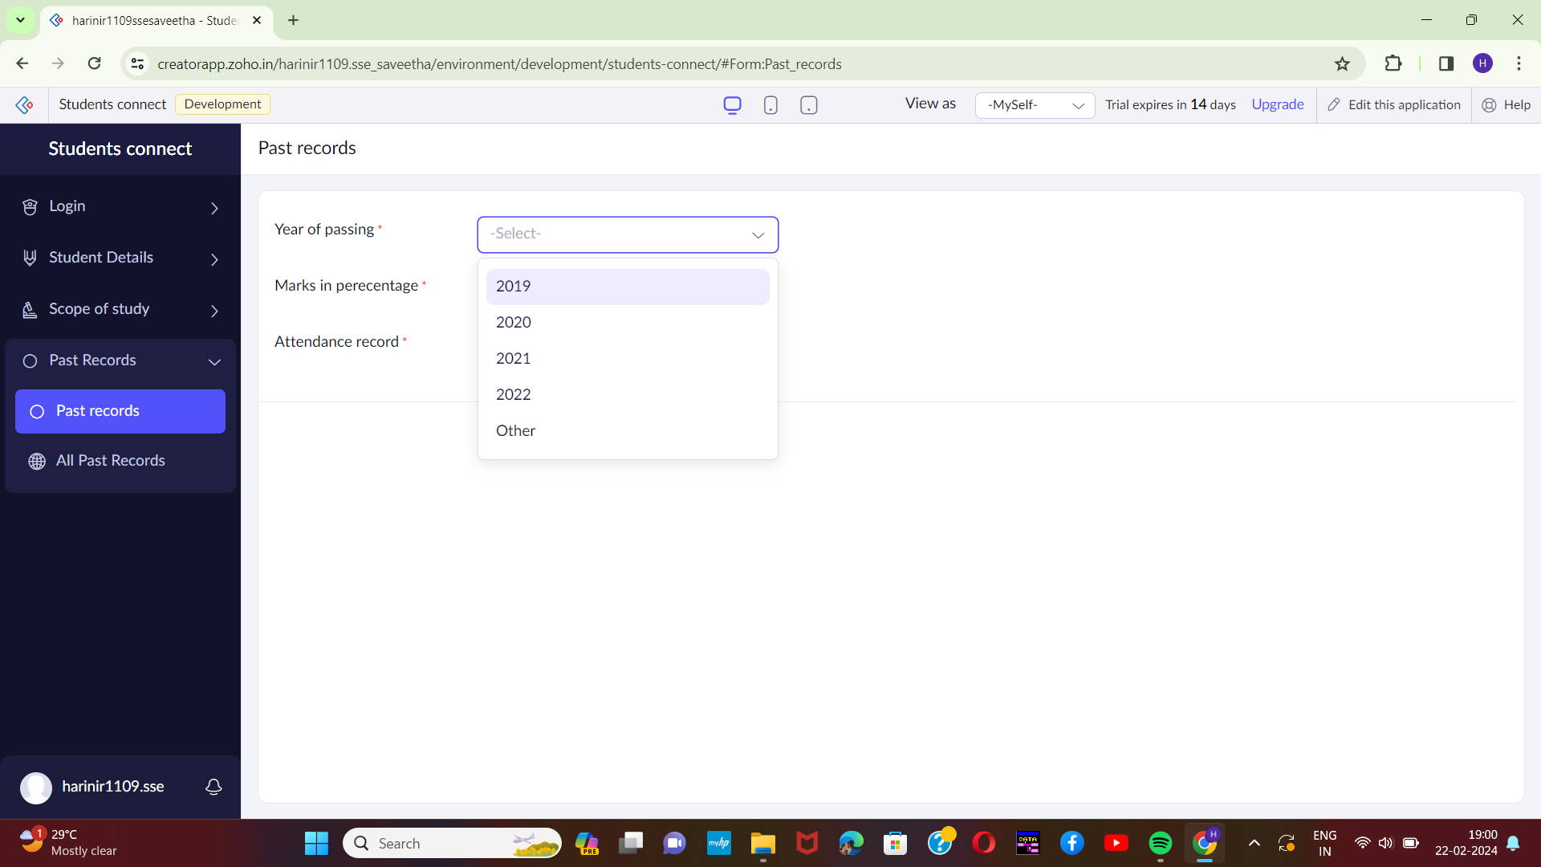[6]

STEP-9:

Next step is to add another form which consists of logout details.

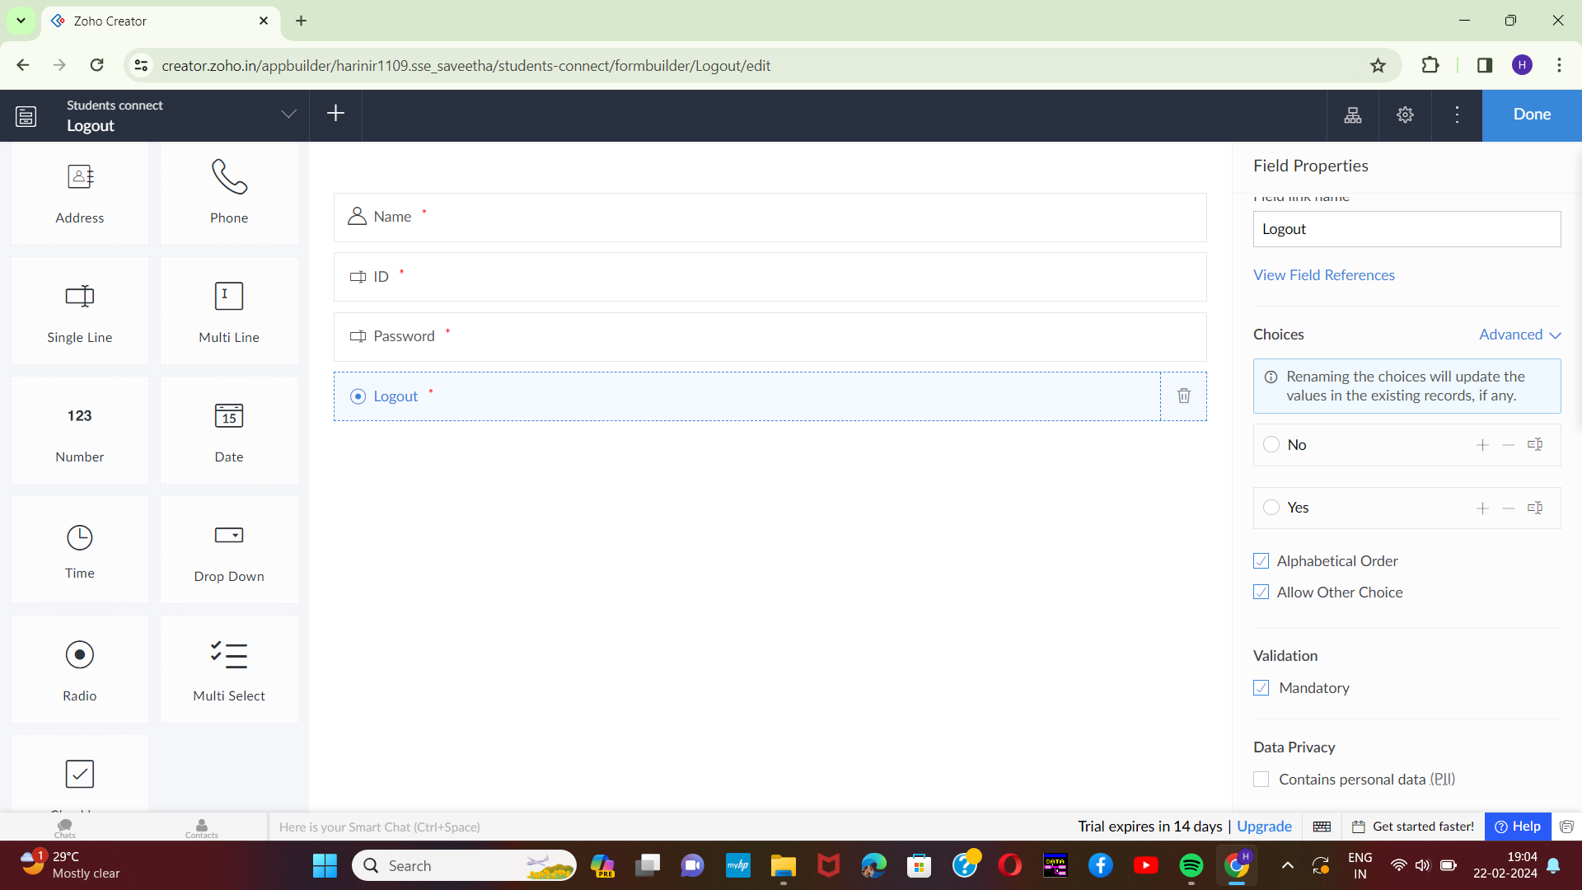[7]

STEP-10:

The last step is to run and execute the logout form and end the program.

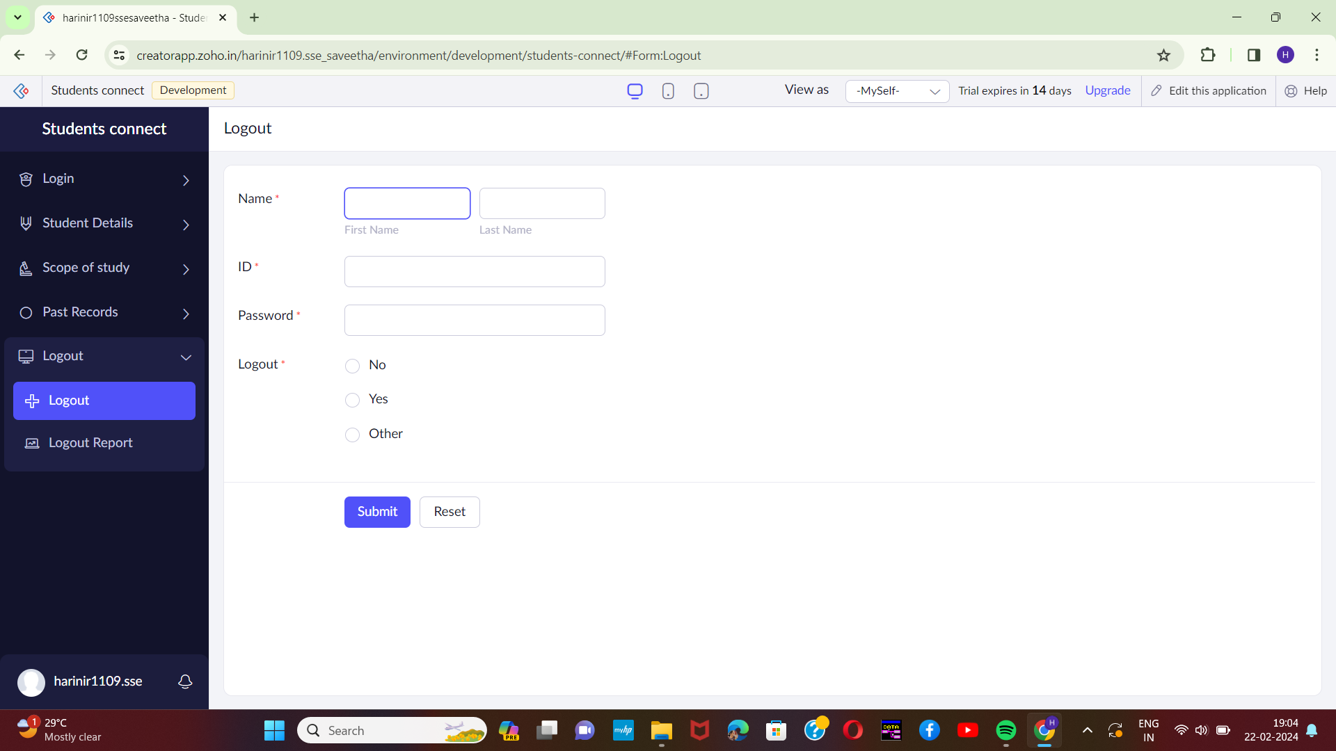

1.
2.
3.
4.
5.
6.
7.